**f. 76r**

no*ta*

[detraccion]

n*ota*

¶

**f. 76v**

¶

no*ta*

¶ca*pitulum* 64 •

¶

no*ta*

[loue]

**f. 77r**

n*ota*

n*ota*

modigy

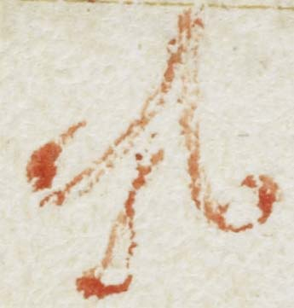

¶

**f. 77v**

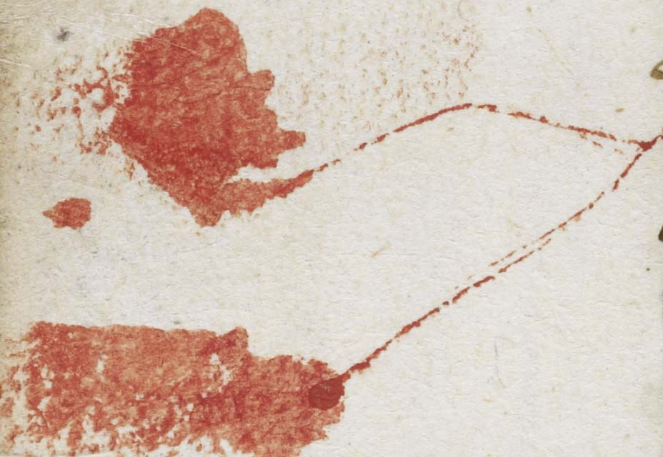

¶ca*pitulum* •65•

¶

**f. 78r**

no*ta* b*e*n*e*

n*ota*

n*ota*

sic i*n* libro to

S • poule

[n*ota*?] 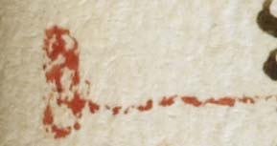

**f. 78v**

fleysse

no*ta* semp*er*

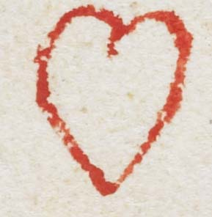

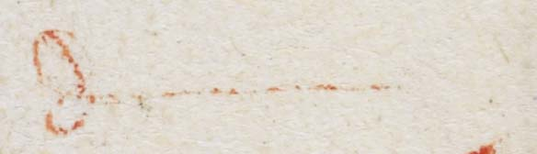

¶ca*pitulum* •66•

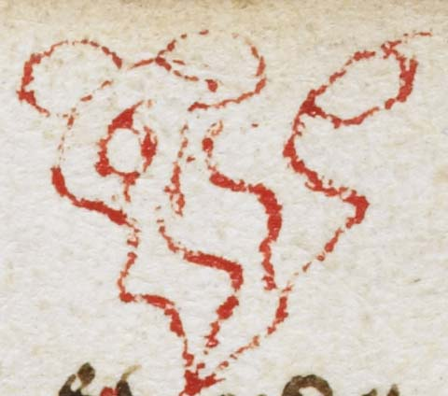

**f. 79r**

gostly labor*ys*

n*ota*

¶ca*pitulum* •67•

n*ota* n*ota*

**f. 79v**

¶

iii •

**f. 80r**

¶

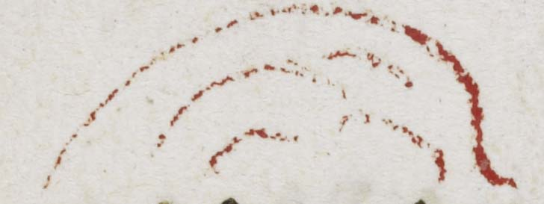

**f. 80v**

­

no*ta* materia*m*

istam :~

¶ca*pitulum* •68•

**f. 81r**

• wystly •

n*ota* [deuot doct*owr*

**f. 81v**

¶

¶ca*pitulum* •69•

**f. 82r**

goyd clarkys

**f. 82v**

¶

¶ca*pitulum* •70•

to o*ur* lade •

**f. 83r**

[ngag?]

¶ca*pitulum* •71•

**f. 83v**

¶

**f. 84r**

¶ca*pitulum* •72•

no*ta* b*e*n*e* •

ei*us* p*er*fecc*i*o*nem*

**f. 84v**

n*ota*

¶

**f. 85r**

father M •

was wont

so to doo ;

¶ca*pitulum* •73•

^lady

+*

n*ota*

**f. 85v**

la*n*gyng loue

¶

no*ta* indul

gencia •

¶ca*pitulum* •74•

¶

no*ta*

**f. 86r**

n*ota*

h • ii •

¶

**f. 86v**

d R • fow­

dyd so

| A sotel & a

|sore te*m*ptac*i*on

in siche a case

we shold be

more stra*n*ge &

bold a gaste

o*wr* gostly enmy

¶ca*pitulum* •75•

Notabile q*uod*

no*ta*

**f. 87r**

n*ota*

¶ca*pitulum* •76•

her husband

**f. 87v**

vow•

Ih*esu* C*rist*

**f. 88r**

caritas di*vina* •

n*ota*

¶ca*pitulum* •77•

no*ta*

/

/

/

dyscretion

**f. 88v**

Responcio •

potestas di*vina*

wyl •

¶

planet*ys*

nota*n*d*um*

**f. 89r**

terys

p*er*f*ect*a caritas

foras mittit ti[morem?]

ma*n*heyd of

cryst :~

h • v •

no*ta*

**f. 89v**

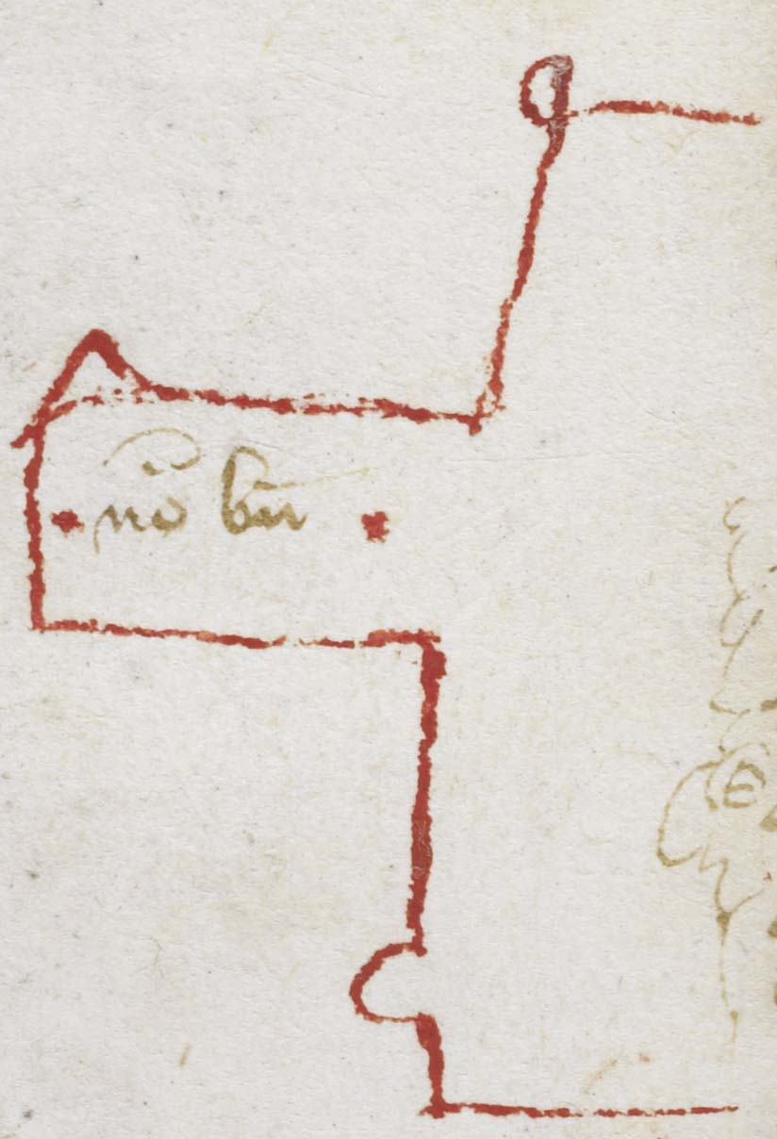

¶ca*pitulum* •78•

**f. 90r**

n*ota*

•)

n*ota*

h • vi •

¶

**f. 90v**

i*n* exe*m*plu*m*

p*ra*er

bona*m* volu*n*t*atem*

¶

no*ta*